 |  | This is an elephant. It has a long nose, called a trunk.
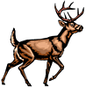 |  | This is a deer. Do you see the antlers on its head? It lives in the forest.
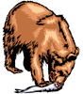 |  | This is a bear. It eats fish. It has large feet, called paws. It can be dangerous.
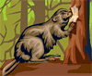 |  | This is a beaver. It lives in the water and is a famous Canadian animal.
 |  | This is a whale. This is the largest animal in the sea.
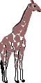 |  | This is a giraffe. It uses its long neck to eat the leaves high up in tall trees. It lives in Africa.
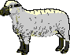 |  | This is a sheep. People get wool from this animal to make clothing.
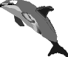 |  | This is a dolphin. It lives in the sea. People think the dolphins are very smart.
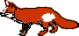 |  | This is a fox. It has red fur, a long tail, and a pointed nose.

